AI in Healthcare

Capstone Project

Explainable AI for Breast Cancer Subtype Classification

Boy Stroo (1061576)
Niels Poldervaart (1006334)
Quinn Rachman (1009001)
Rick van Alphen (1006306)
Wesley Zwaal (1026606)

Group 3
GitHub Repository

Date of Submission: 16-November-2025
Revision 2

Abstract

Accurate molecular subtyping of breast cancer is fundamental for guiding patient treatment, but analyzing high dimensional RNA-Seq data with interpretable models remains a challenge. This research presents an explainable AI (XAI) framework for breast cancer subtype classification using RNA-Seq data. We collected RNA-Seq data from The Cancer Genome Atlas Breast Invasive Carcinoma (TCGA-BRCA) dataset and applied a systematic preprocessing and validation pipeline.

We compared three classifiers (XGBoost, Random Forest, and Logistic Regression) with three feature selection methods (SelectKBest, Recursive Feature Elimination, and SelectFromModel). Our best model, a Logistic Regression classifier using features selected by SelectFromModel (which used Random Forest as the model), avoided the significant overfitting seen in the other tree-based models and achieved a final F1-Macro score of 0.9010 after hyperparameter tuning. SHAP (SHapley Additive exPlanations) was used to interpret the final model's predictions, identifying key gene drivers, such as ROPN1 and MYB, for specific subtype classifications.

1. Introduction
Breast cancer is the most prevalent cancer among women globally. Although breast cancer is a complex disease, it can be subdivided into distinct molecular subtypes that are widely recognized: Luminal A (LumA), Luminal B (LumB), HER2-positive (Her2) and triple-negative (TNBC) [1, 2]. Accurate identification of these subtypes is fundamental to determining patient treatment. RNA-Seq data has proven to be incredibly useful for characterizing these subtypes. However, analyzing the subtle patterns of RNA-Seq data using traditional statistical methods is nearly impossible, since RNA-Seq datasets can easily contain thousands of genes across multiple samples. Fortunately, the emergence of Machine Learning (ML) in the medical sector has opened new opportunities for analyzing genomic data. Machine learning models are capable of processing massive RNA-Seq datasets efficiently, while also being incredibly accurate [3].

This research addresses the gap between high-performing classification models and interpretability by creating an explainable AI framework for breast cancer subtype detection. By combining tree-based algorithms with SHAP (SHapley Additive exPlanations), our goal was to create a machine learning model that provides interpretable explanations, while maintaining its high accuracy. For this research, we used RNA-Seq data from The Cancer Genome Atlas Breast Invasive Carcinoma (TCGA-BRCA) dataset to identify breast cancer subtypes.

The primary objectives are as follows: first, to develop and compare multiple machine learning models for multi-class breast cancer subtype classification using high-dimensional RNA-Seq data. Secondly, to optimize model performance using systematic feature selection and hyperparameter tuning. Lastly, to generate interpretable visualizations that reveal cohort-level patterns and biomarkers for subtype division. With this work, we seek to advance personalized treatment for breast cancer patients through accurate and interpretable subtype differentiation.

This paper proceeds with a review of related research work on breast cancer classification. Next, we provide a detailed description of our overall workflow, which includes machine learning techniques, feature selections strategies, and validation methods. Then, the dataset and our preprocessing pipeline are discussed before moving on to our experimental results. Finally, we discuss ethical considerations regarding machine learning for breast cancer research, and outline directions for future research.

2. Related Work

2.1 Breast Cancer Subtype Classification and Current Approaches
Breast cancer is the most common cancer in women worldwide. It is a highly heterogeneous disease with multiple distinct subtypes. The following four subtypes of breast cancer are widely recognized: Luminal A (LumA), Luminal B (LumB), HER2-positive (Her2) and triple-negative (TNBC) where the majority of the TNBC subtype consists of basal-like subtypes [1, 2]. Correct identification of the breast cancer subtype is critical for proper treatment of patients [4].

A recent study created an AI model for binary breast cancer subtype classification based on RNA-Seq data. They created a binary classifier for each subtype and could make accurate predictions on unseen data, reaching up to 96% accuracy for certain subtypes [5]. Similarly, a group of researchers created an explainable AI model for breast cancer classification, focusing on the privacy of the patients while maintaining performance, achieving an accuracy of 97.59% [6]. While one study focuses on subtype classification, the other focuses on explainability and privacy. It is important for the treatment of patients that these insights must be combined. The resulting explainable model would be able to classify subtypes so that the patients can get specific treatment for their needs.

2.2 Explainable AI in Cancer Genomics
The emergence of explainable artificial intelligence (XAI) techniques addresses the interpretability limitations of machine learning models. As Morabito et al. highlights, "while very powerful, DL models are in general not immediately interpretable, meaning that it is difficult to understand the causal relationship between the inputs and their outcomes" [7]. This lack of interpretability is problematic in clinical genomics, where understanding the reasoning behind the prediction is as important as the classification accuracy for guiding a patient’s treatment.
Among XAI approaches, Shapley Additive exPlanations (SHAP) stands out for clinical applications. SHAP provides a unified framework for model interpretation by assigning importance values to each feature for individual predictions [8]. For breast cancer research, Khater applied SHAP to create “An explainable Artificial Intelligence model for the classification of breast cancer” [9]. Similarly, Mamatjan et al. used SHAP for brain cancer classification, making "explainable patient-specific decisions while tailoring the provided recommendations based on each patient's characteristics" [10].

Research Gap: Explainable AI for Breast Cancer Subtype Classification
Despite significant advances in both breast cancer subtype classification and XAI in cancer research, a gap exists in combining these domains. Current breast cancer subtype classifications models achieve impressive results but lack interpretability to explain their predictions at both cohort and patient-specific levels [11, 12].
The ability to identify patient-specific biomarkers using explainable models could transform treatment approaches. As demonstrated in other cancers, "patient-specific biomarkers can be used for targeted therapy leading to precision medicine which the earlier computational studies fail to identify" [13]. This is valuable for breast cancer patients, where subtype-specific treatments have significantly improved outcomes for patients with a more advanced stage of breast cancer [4].

3. Methodology

3.1 Project Workflow
Our model aims to develop an explainable AI model for detecting Breast Cancer subtypes using RNA-Seq data. For this, we have designed a workflow which is shown below in Fig. 1.
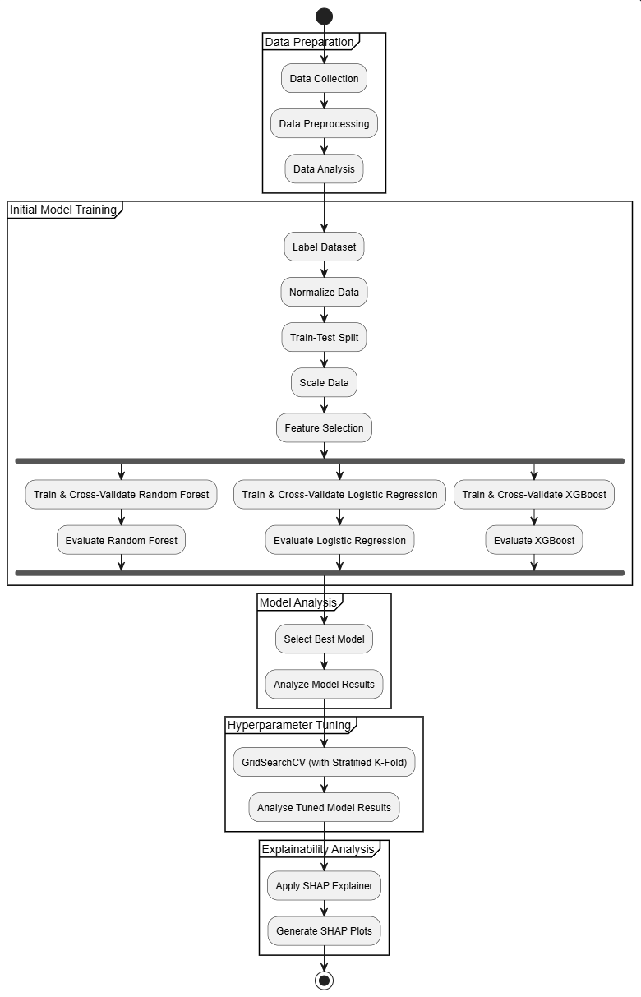
Fig. 1. Workflow of the study for detecting Breast Cancer subtypes using RNA-Seq data and XAI.

The workflow of this study is as follows: First, we collect the breast cancer genomic data from GDC. After collecting the data, after collecting the data, we do some preprocessing and basic analysis to understand the data better. Then we do some initial preprocessing and cleaning and some basic analysis to understand the data better. Then we merge the datasets together, label it with the correct subtypes and normalize the data. After this, we create the train-test split and apply a standard scaler to the training data and do some basic variance- based filtering. After these steps, we do our initial model training, where we train 3 different tree-based, after which we evaluate the different models and choose the best performing model. We hyperparameter tune the best performing model, analyze the tuned results and apply SHAP to generate interpretable visualizations of the results.

3.2 AI/ML Techniques
For our breast cancer subtype detection, we will implement and compare multiple tree-based ensemble learning algorithms. These algorithms have demonstrated strong performance in genomic classification tasks and offer excellent compatibility with our explainability requirements. We will evaluate the following models:

3.1.1 Random Forest
Random Forest (RF) constructs multiple decision trees from random data subsets to create a robust ensemble model. RF is known for its high predictive accuracy and has become one of the most widely used methods for classification tasks [14]. Multiple studies demonstrated the effectiveness of RF for classification of high-dimensional mixed-type RNA-Seq data [15, 16].

3.1.2 Logistic Regression
Logistic Regression (LR) is a versatile and widely used ML model for binary classification. It provides a framework for understanding and predicting binary outcomes. It examines the relationship between the predictor variables and the output variables. LR is used when the outcome is categorical, like breast cancer subtype classification [17].

3.1.3 Extreme Gradient Boosting (XGBoost)
XGBoost builds sequential trees where each new tree corrects errors made by previous ones, effectively handling non-linear relationships in genomic data. Multiple studies show promising results when using XGBoost for their cancer classification, reaching accuracies of up to 94% and showing great results while working with high-dimensional data and even multi-class classification tasks, making it a promising candidate for our breast cancer subtype classification [18, 19].

3.2 Technical Implementation
Our technical stack combines bioinformatics tools with advanced machine learning capabilities to process RNA-Seq data, develop accurate cancer detection models, and provide interpretable results:
- Python: Core programming language providing access to specialized machine learning and bioinformatics libraries needed for RNA-seq data analysis.
- Scikit-learn: Implements fundamental ML workflows including train-test splitting, Random Forest, Logistic Regression, and cross-validation.
- XGBoost: Optimized gradient boosting implementation that excels with high-dimensional RNA-seq data through efficient handling of sparse features and regularization options.
- Pandas/NumPy: Essential libraries for data manipulation.
- SHAP (SHapley Additive exPlanations): Provides interpretable insights into black-box tree models to create explainable AI.
- Matplotlib/Seaborn: Creates visualizations of model performance metrics and SHAP explanations needed for model interpretation.
- Jupyter Notebooks: Interactive development environment that enables step-by-step RNA-seq data exploration, model development with inline visualizations, and creation of shareable, reproducible workflows for collaborative research.

3.3 Feature Selection
Given the high dimensionality of RNA-Seq data, effective feature selection is crucial for our breast cancer subtype classification model. For our project we tried the following 3 different methods for feature selection:
- SelectKBest (SKB): Removes all but k highest scoring features, leaving only the most statistically significant genes for our breast cancer subtype classification.
- Recursive Feature Elimination (RFE): Iteratively removes the least important features by recursively training the model and dropping the least impactful features, leaving only the most impactful features for our subtype classification. In our project we used Logistic Regression model.
- Select From Model (SFM): Selects genes based on a model’s feature importance, keeping only the most informative features based on a relevance threshold. In our project we used Random Forest model.

3.4 Performance Metrics
For evaluating our subtype classification models, we track the following metrics to measure both overall accuracy and per subtype performance:
- Accuracy: Overall performance of the model for the correctly classified breast cancer subtypes across all predictions.
- Precision, Recall, F1-Score: Evaluate per-subtype classification performance, with the F1 score balancing precision and recall.
- Standard Deviation: Measures consistency of F1-scores across cross-validation folds.
- ROC-AUC: Measures each sub-type’s classification quality by visualizing the true positive rates and the false positive rates.
- Learning Curve: Visualizes model performance vs training set size, showing whether additional data would improve the model’s results.
- Confusion Matrix: Provides a detailed overview of predictions vs the actual subtypes. Revealing which subtype misclassifications occur most frequently.

3.5 Validation Methods
To ensure great model performance and prevent overfitting, we use the following validation strategy:
- Stratified K-Fold Cross-Validation: Splits data into K folds while maintaining subtype distribution in each fold. This ensures that the model is reliable and prevents bias towards the majority classes.

4. Dataset and Preprocessing

4.1 Data Acquisition
We made use of the Genomic Data Commons (GDC) database to create our cohort. For our data, we used samples from The Cancer Genome Atlas Breast Invasive Carcinoma, abbreviated as TCGA-BRCA. The dataset consisted of 1215 samples of RNA-Seq data. Every sample had its own file, which made it so that these files needed to be combined during the preprocessing phase.

We also included an excel sheet which contained genes from the projects along with their assigned PAM50 subtype.4.2 Data Cleaning and Annotation

4.2 Data Cleaning and Annotation
Our preprocessing involved separate different steps which included the following:
- Combining multiple tsv files into one singular parquet file (PQ). Parquet is a storage format widely used for efficient data storage.
- Cross-referencing genes from our dataset with the excel sheet that contained the PAM50 subtypes.
- Removing all NaN values.

4.2.1 Combining
Our cases were separated into a file per case, so first we had to combine all the files into one single dataset. Every file had multiple fields like: unstranded and stranded_first, but it also had some normalized fields like: tpm_unstranded (Transcripts Per Million, TPM) and fpkm_unstranded (Fragments Per Kilobase Per Million, FPKM).

We selected tpm_unstranded as our main metric. We chose it because TPM is a good baseline to work with from RNA-Seq and corrects for counting biases that you find in raw counts [20].

The result was a dataset which included sample_id’s and the gene_id’s; the sample_id’s were later used for cross-referencing.

4.2.2 Sample Annotation
With the complete finalized dataset, we then started cross-referencing with the excel sheet. The excel sheet contained patient data from the TCGA-BRCA project which included multiple pieces of information, the most important being the PAM50 subtype. This was the main driver for our classification model to train on.

4.2.3 Handling Missing Data
Now with the finalized dataset which included the subtypes, we checked for any NaN values. These could occur if, at the cross-reference part, a subtype was not found. In our case, seventy samples did not match a subtype from the excel sheet and were therefore removed.

4.3 Data Transformation and Filtering
To prepare the RNA-Seq data for machine learning analysis, we implemented a systematic pipeline designed to reduce dimensionality while preserving the most biologically relevant and statistically informative genes. Given the high-dimensional nature of RNA-Seq data with 60,661 genes, effective feature selection was crucial for computational efficiency and model interpretability.

We first applied a log2 transformation (log2(x + 1)) over the whole dataset to normalize the RNA-Seq count data. Then, we split the data and applied a StandardScaler on the training and test data so that all features contributed equally to model training, preventing genes with higher baseline expression from dominating the analysis. The last step was to apply constant variance filtering to remove any constant features [21].

4.4 Final Dataset Characteristic
The dataset exhibited a slight class imbalance with the LumA class being the most represented, as shown in Figure 2. The class imbalance being not that big meant we did not have to take extreme measures to balance them out; regularization within the logistic regression model would handle the class imbalance. We also prioritized f1-macro in our scoring when we were going through the hyperparameter tuning process, which takes into account the class imbalance.

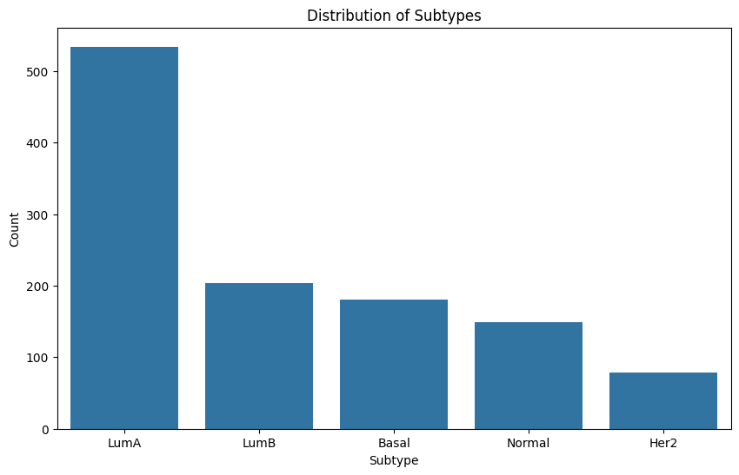
Fig. 1 Class imbalance diagram

5. Experiments and Results
This chapter details the experimental setup, model evaluation, and results of our study. We begin by outlining the experimental parameters, followed by a comparative analysis of our initial models. We then describe the hyperparameter tuning process for the best-performing model and evaluate its final performance. Finally, we apply Explainable AI (XAI) techniques to the optimized model to interpret its predictions and identify key genetic features.

5.1 Experimental Setup
As described in Chapter 3 (Methodology), our primary experiment involved comparing three machine learning algorithms (Logistic Regression, Random Forest, and XGBoost) combined with three feature selection techniques (RFE, SelectFromModel, and SelectKBest). This created a total of nine distinct pipelines.

All experiments were conducted using the preprocessed TCGA-BRCA dataset detailed in Chapter 4. Model performance was evaluated using stratified 5-fold cross-validation, with the F1-Macro score as the primary metric to account for the slight class imbalance noted in Figure 2. The overfitting_gap was used as a key indicator of model generalization.

5.2 Model Selection and Baseline Performance
The initial experiment aimed to identify the most promising and generalizable model pipeline for hyperparameter tuning.

5.2.1 Comparative Analysis of Models
All nine pipelines were trained and evaluated. The results, are presented in Table 5.1.
model | mean_val_f1 | std_dev | mean_train_f1 | overfitting_gap
logistic_regression_sfm | 0.8942 | 0.0371 | 0.9603 | 0.0661
logistic_regression_skb | 0.8766 | 0.0260 | 0.9664 | 0.0898
random_forest_skb | 0.8861 | 0.0114 | 1.0000 | 0.1139
xgboost_sfm | 0.8814 | 0.0227 | 1.0000 | 0.1186
xgboost_skb | 0.8813 | 0.0144 | 1.0000 | 0.1187
random_forest_sfm | 0.8717 | 0.0188 | 1.0000 | 0.1283
logistic_regression_rfe | 0.8082 | 0.0460 | 0.9565 | 0.1484
random_forest_rfe | 0.8412 | 0.0202 | 1.0000 | 0.1588
xgboost_rfe | 0.8341 | 0.0260 | 1.0000 | 0.1659
Table 5.1: Comparative Performance of Model Pipelines
The logistic_regression_sfm (Logistic Regression with SelectFromModel) pipeline was selected as the best baseline model. It achieved a good validation F1-score (0.8942) and had the smallest overfitting gap (0.0661), which indicates it generalized better than the other models. Both Random Forest and XGBoost models, while getting high scores, looked like they were overfitting (gap > 0.11) with perfect training scores (1.0000).

5.2.2 Baseline Model Evaluation
The selected logistic_regression_sfm model was further analyzed. The learning curve (Figure 5.1) shows that the training and cross-validation scores are converging, suggesting that the model benefits from the training data without significant overfitting.
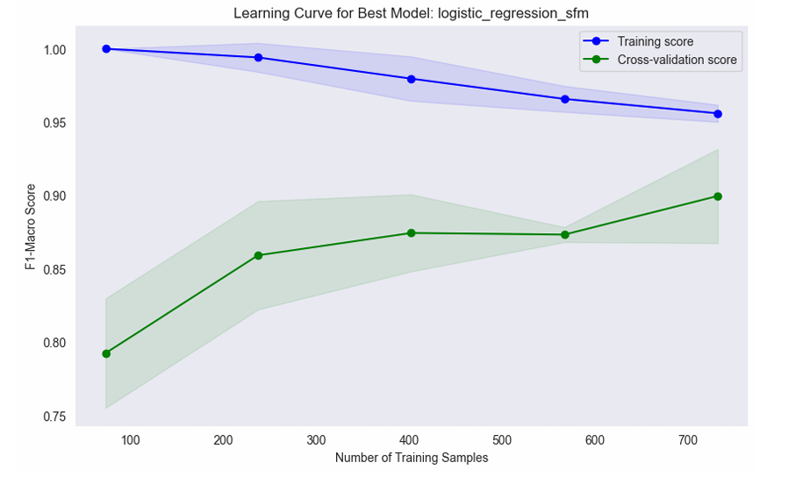 Figure 5.1: Learning Curve for the Baseline logistic_regression_sfm Model.
The confusion matrix for the baseline model (Figure 5.2) shows it's predicted well, especially for the LumA (391/423 correct), Basal (142/146 correct), and Normal (105/117 correct) subtypes. It seems to get most confused between LumB and LumA (26 LumB samples were misclassified as LumA) and with the Her2 subtype.
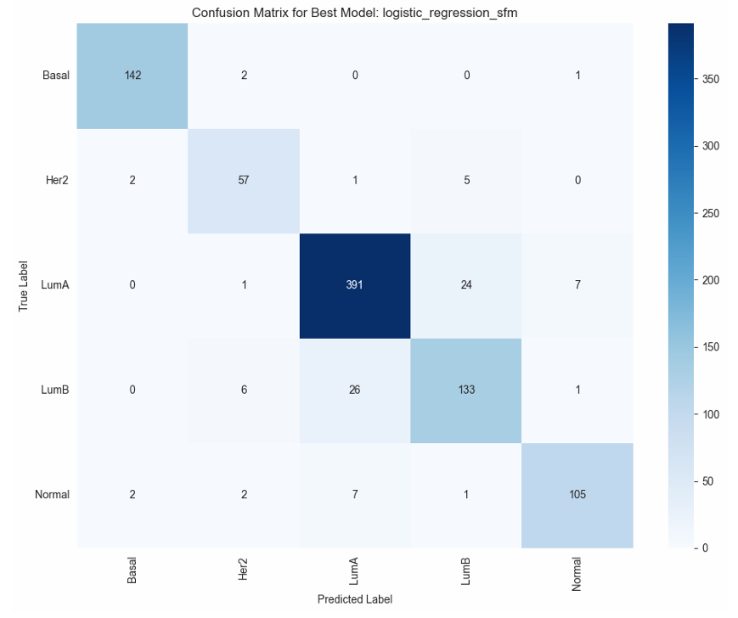 Figure 5.2: Confusion Matrix for the Baseline logistic_regression_sfm Model.
The one-vs-rest ROC curves (Figure 5.3) also looks good. The model is doing a great job telling the classes apart, with AUC scores at or above 0.986 for all classes and even getting perfect (1.000) AUC scores for Basal and Normal.
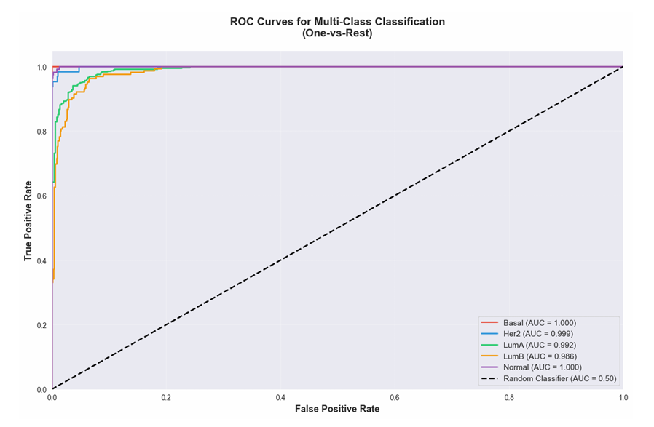
Figure 5.3: ROC-AUC Curves for the Baseline logistic_regression_sfm Model.

5.3 Hyperparameter Tuning and Final Model Performance
The logistic_regression_sfm pipeline was optimized using GridSearchCV to find the best combination of hyperparameters.

5.3.1 Tuning Results
The grid search explored 120 different parameter combinations. The best-performing model achieved a final cross-validated F1-Macro score of 0.9010. The optimal parameters were:
- Feature Selection (SelectFromModel): max_features = 50
- Model (LogisticRegression): C = 10, class_weight = None, penalty = 'l1', solver = 'saga'
This result is an improvement over the baseline model's score of 0.8942.

5.3.2 Final Tuned Model Evaluation
The optimized model was re-evaluated using the same metrics. The learning curve (Figure 5.4) shows a similar trend to the baseline, with a high cross-validation score, confirming the model's stability.
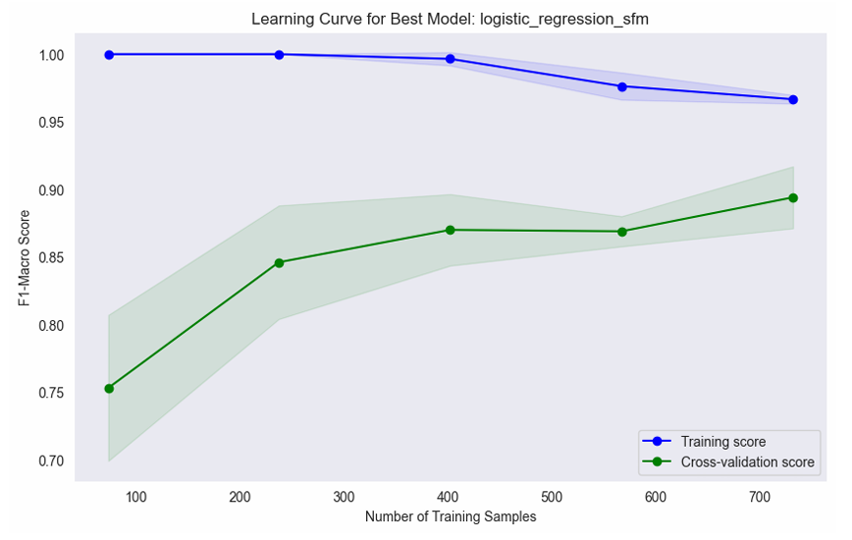
Figure 5.4: Learning Curve for the Final Tuned Model.
The confusion matrix for the final tuned model (Figure 5.5) shows an improvement in accuracy. Compared to the baseline (Fig 5.2), the tuned model correctly identified more Her2 (59 vs 57), LumB (137 vs 133), and Normal (108 vs 105) samples. This suggests it got better at classifying minority classes, which shows the tuning was worthwhile.

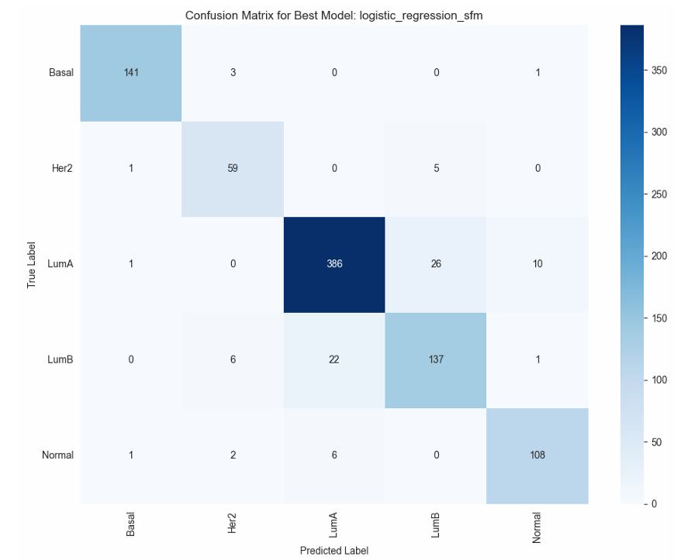 Figure 5.5: Confusion Matrix for the Final Tuned Model.
The ROC-AUC curves (Figure 5.6) for the final model also slightly increased, backing up that it's a solid classifier across all subtypes.

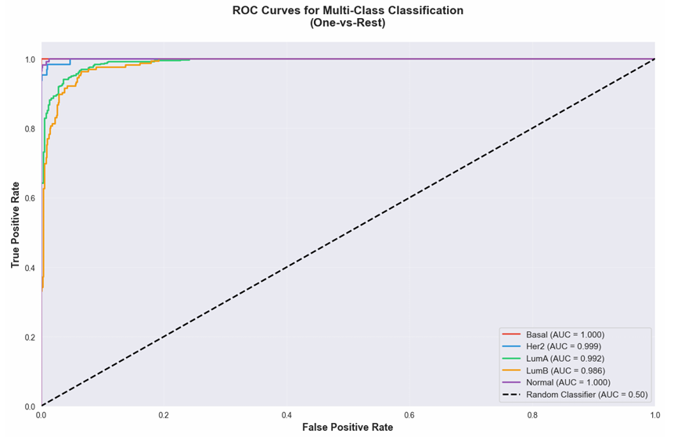
Figure 5.6: ROC-AUC Curves for the Final Tuned Model.

5.4 Explainable AI (XAI) Results with SHAP
To address our research goal of creating an interpretable model, we applied SHAP (SHapley Additive exPlanations) to the final, tuned logistic_regression_sfm model. This allowed us to quantify the impact of each of the 50 selected genes on the model's predictions.

5.4.1 Global Feature Importance
SHAP values were aggregated to determine which genes had the largest overall impact on the model's predictions. The top 10 most influential genes are listed below.
Rank | Gene Symbol | Global SHAP Value
1 | ROPN1 | 10.1653
2 | MYB | 6.7379
3 | CCDC170 | 6.4053
4 | ANXA1 | 6.2599
5 | RGMA | 5.7576
6 | FOXCUT | 5.6368
7 | ANKRA2 | 5.4158
8 | DMD | 4.8729
9 | TBC1D9 | 4.5955
10 | SKA1 | 4.2224

Table 5.2: Top 10 Globally Important Features (Genes)

5.4.2 Subtype-Specific Biomarker Analysis
While global importance is useful, the primary benefit of SHAP is understanding how features impact predictions for specific classes. We analysed the SHAP values for key genes across each of the five subtypes, using both the Mean Absolute SHAP and the Mean SHAP to respectively represent the influence strength and directional impact.

The ROPN1 gene (Figure 5.7) shows the strongest influence of any gene. Plot A shows it is the most important feature for identifying the LumB subtype, with the highest mean absolute SHAP value (5.9766), and it also has a significant influence on the Basal subtype (2.3670). Plot B reveals the direction of this impact, showing that the gene's features decrease the model's score for the LumB subtype (-1.6014) while increasing the score for Basal (+0.8699) and Normal (+0.4062). The model also learned this gene has no influence on the Her2 classification (0.0000).
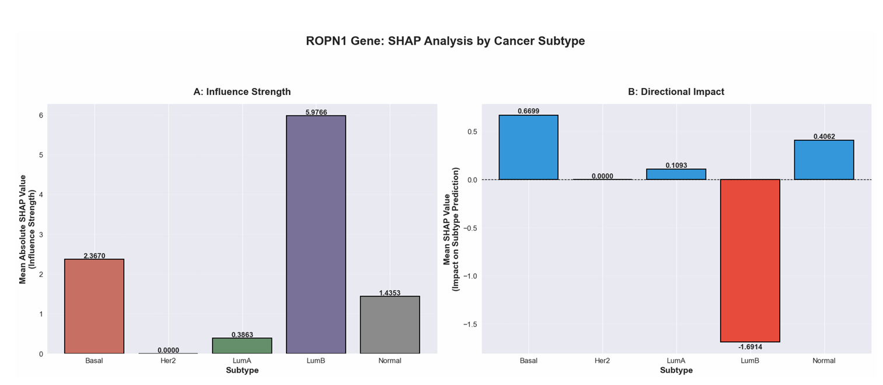Figure 5.7: SHAP analysis of ROPN1 gene influence strength and direction per subtype.

The MYB gene (Figure 5.8) was the second most important feature globally. Plot A shows it is most influential for predicting the Normal (2.9003) and Her2 (2.5521) subtypes. Plot B explains this, showing that the gene’s features on average increase the model’s score for the Normal subtype (+0.2692) but decrease the score for the Her2 subtype (-0.2389). This opposing directional impact makes it an important gene for distinguishing between these two classes. The model also learned that this gene has no influence on LumB predictions (0.0000).
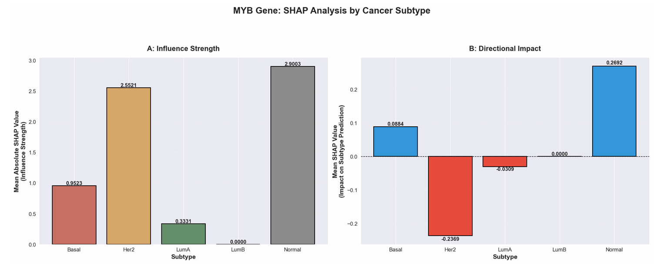Figure 5.8: SHAP analysis of MYB gene influence strength and direction per subtype.
The CCDC170 (Figure 5.9) shows broad influence across multiple subtypes. Plot A shows high influence for LumB (2.1605), LumA (1.9629), and Her2 (1.8920). Plot B shows the impact is not uniform. The gene's features increase the model's score for Her2 (+0.3548), but decrease the score for both LumA (-0.3651) and LumB (-0.4051). This suggests that CCDC170 is an important differentiator that helps the model separate the Her2 subtype from the two Luminal subtypes.
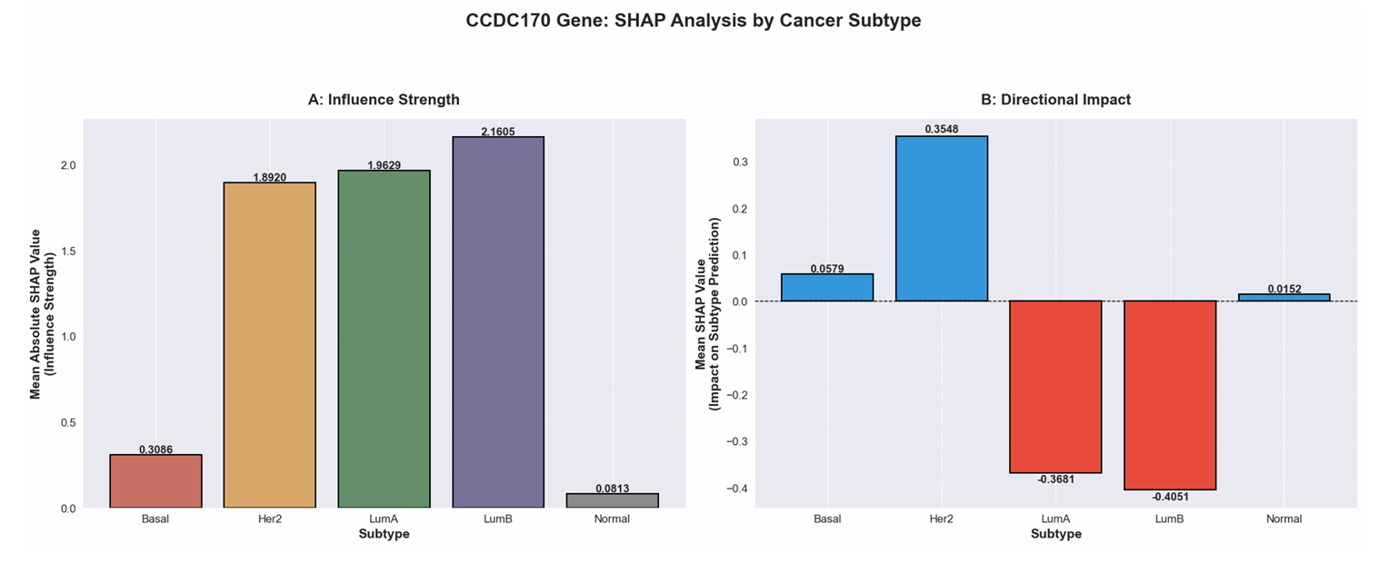 Figure 5.9: SHAP analysis of CCDC170 gene influence strength and direction per subtype.

6. Discussion and Evaluation

This chapter analyzes the experimental results from Chapter 5, interpreting the final model's performance in the context of our research goals and existing literature. We evaluate the biological relevance of the biomarkers identified through our Explainable AI (XAI) analysis and conclude by addressing the study's limitations and proposing directions for future research.

6.1 Interpretation of Model Performance and Generalization
This study successfully developed a robust machine learning pipeline for breast cancer subtype classification, which resulted in a Logistic Regression model that achieved a final F1-Macro score of 0.9010. This result is interesting, as it shows that a highly interpretable, linear model can achieve strong performance on complex, high-dimensional genomic data.

An important factor in our model selection was generalization. The chosen logistic_regression_sfm pipeline's performance (Table 5.1) showed a clear difference from its tree-based counterparts. While Random Forest and XGBoost achieved perfect training scores, their larger overfitting gaps (0.1139 - 0.1659) suggested they were memorizing the training data rather than learning from it. In contrast, our final model's smaller gap (0.0661), achieved through l1 regularization, indicates a more generalizable classifier.

6.2 Analysis of XAI-Identified Biomarkers
The primary contribution of our work is the identification of a small, interpretable panel of 50 genes. Our SHAP analysis (Section 5.4.2) provided insight into why the model makes its decisions.

Analysis of ROPN1 (LumB)
Our SHAP analysis for ROPN1 (Figure 5.7) shows that it has the strongest impact on our model. The plots indicate that ROPN1 is a powerful driver for classifying the Basal subtype (a high positive push) and a strong driver against classifying the LumB subtype (a deep negative push).

This finding matches existing research [23], which identifies ROPN1 as a key biomarker for Basal-like breast cancer, also known as Triple-Negative Breast Cancer (TNBC). Studies confirm that ROPN1 expression is highest in Basal subtypes and significantly lower in Luminal A and B tumors. This gene is also linked to a more aggressive disease, which directly explains why our model learned that a high ROPN1 signal points strongly to the Basal subtype.

Analysis of MYB (Her2 & Normal)

The SHAP analysis for MYB (Figure 5.8) revealed it as a key differentiator between the Her2 and Normal-like subtypes. Its value pushed the model toward predicting Her2 and strongly away from predicting Normal-like. This distinction makes biological sense. The "Normal-like" subtype is defined by its gene expression profile resembling normal breast tissue, whereas MYB is a known proto-oncogene and a critical "hub" for tumors driven by the HER2 pathway [24], The model accurately learned that a strong MYB signal is indicative of a HER2-enriched tumor and against a "Normal-like" classification.

Analysis of CCDC170 (LumA/B & Her2)
The model's learned behavior for CCDC170 (Figure 5.9) highlights a more complex interaction. SHAP plots showed this gene pushing the model away from both LumA and LumB subtypes, but toward the Her2 subtype. This is a more questioning finding, as CCDC170 is typically associated with Luminal subtypes [25]. This suggests the model may be capturing a relationship, between this gene and the Her2 pathway that could be looked at in future work.

6.3 Limitations
Despite these good results, limitations must be acknowledged, which provide directions for future work.

First, the model was trained exclusively on the TCGA-BRCA dataset. While comprehensive, this dataset may not capture the full genetic diversity of all patient populations, potentially limiting the model's generalizability. Future work should try to validate the model and its 50-gene panel on independent, external cohorts.
Second, our selection of Logistic Regression, while a good pick for interpretability and avoiding the overfitting seen in our tree-based models (Table 5.1), is a linear model. It may not capture complex, non-linear gene interactions that a more advanced, well-regularized model (such as a deep neural network) could.
Finally, while SHAP summary plots (Figures 5.7-5.9) reveal feature importance and directional impact, they do not explicitly map this impact to high versus low gene expression levels. Our biological interpretation relied on cross-referencing literature to infer these relationships. It is also important to remember that SHAP values explain the model's learned correlations, which do not inherently prove a direct causal link in biology.

7. Ethical Considerations
There are several ethical concerns regarding our project that need to be identified and addressed. These concerns are related to privacy, data handling, fairness, bias, accountability, and explainability.

7.1 Privacy & Data Handling
A possible privacy concern is the lack of informed consent. As we’re working with data that has been collected retrospectively, which was not originally intended for our specific use case, informed consent could be an issue. Since we cannot collect the data ourselves, informed consent is a limiting factor for our dataset options. We will read through the documentation regarding consent and data usability, provided with the datasets, and choose a dataset which aligns with our use case.

Another privacy concern is the possibility of re-identifiability. The dataset we will use is open access, meaning it’s already publicly available for everyone. However, we will keep the possible privacy risk in mind and focus on minimizing re-identifiability. The problem that arises with our dataset is genomic data, which we need to use for our research project. Genomic data is inherently re-identifiable as it contains biological identifiers. Despite this, we will try to reduce re-identifiability by removing unneeded columns when training the AI model. Furthermore, we will shorten the genomic data to add a layer of de-identification and improve model performance. Lastly, we will not mention or use any raw data in our research, only aggregated data, to make sure data is handled carefully.

7.2 Fairness & Bias
Data directly related to unfairness is not included in the datasets. However, unfairness might unknowingly occur when selecting specific features. During the feature selection phase, we will make sure to inspect and get rid of any features that might cause unfairness towards any groups of people.

Another ethical issue could be bias. To reduce bias, we will remove outliers and perform data handling techniques to deal with the remaining forms of bias. These techniques could be undersampling, oversampling, or distributing different weights, depending on the model's performance.

7.3 Accountability
For AI models in healthcare, it’s important to discuss accountability, because AI models should support clinical decisions instead of replacing them. Thus, responsibility for final medical decisions should remain with qualified healthcare professionals. So, the model we created is meant as a decision-support tool and not a self-diagnosing system.
There are still some accountability aspects to be held for the developers, as they should be accountable for the way the model is trained, validated, and documented. So, all assumptions, limitations, and known failures should be communicated clearly to the users. So that users can make informed decisions when interpreting the models' output.

7.4 Explainability
AI models need to be explainable to be useful in practice. The explanation is needed to detect possible false negatives and false positives, so the correct diagnosis can be made. We will add explainability using SHAP. Furthermore, we will use simple machine learning algorithms to improve its explainability. Lastly, we will be transparent with our model’s limitations, so the model can be applied for the correct use cases.

8. Conclusion and Future Work
This study set out to develop a high performing, interpretable machine learning framework for the classification of breast cancer subtypes using high-dimensional RNA-Seq data. By systematically comparing multiple model- and feature selection pipelines, we developed a final model that balances high accuracy with the crucial need for clinical explainability.

8.1 Key Contributions
This study successfully developed an explainable machine learning pipeline for breast cancer subtype classification using RNA-Seq data. Our main contributions include:
- Demonstrating that a Logistic Regression classifier, when combined with SelectFromModel (SFM) feature selection, can achieve high performance (F1-Macro of 0.9010).
- Establishing that this simpler, regularized model provides a superior balance of generalization and performance, avoiding the significant overfitting observed in more complex tree-based ensembles like Random Forest and XGBoost in this application.
- Applying SHAP to this interpretable model to identify and validate the biological relevance of key genetic drivers for specific subtypes, such as ROPN1 (for Basal/LumB) and MYB (for Her2/Normal subtypes).

The work addresses a key research gap by prioritizing interpretability alongside accuracy, achieving a high performing model where the trade-off between performance and explainability is minimal.

8.1.1 Contributions to Knowledge and Practice
Our research adds to the growing body of work applying explainable AI to cancer genomics. The study demonstrates that an interpretable linear model can effectively identify biologically meaningful gene signatures from high-dimensional RNA-Seq data. The systematic evaluation of nine distinct model- and feature selection pipelines (Table 5.1) provides a reproducible template for similar studies. From a practical standpoint, we showed that standard machine learning tools can be combined to create an interpretable diagnostic aid, with SHAP analyses providing gene specific insights into subtype differentiation.

8.2 Future Work and Improvements
While this analysis provides a strong validation of the model, it is important to acknowledge its limitations, which in turn suggest clear directions for future work:
- External Validation: The model was trained exclusively on the TCGA-BRCA dataset. Testing the model on independent, external datasets from different institutions and patient populations is a critical next step to establish its true generalizability and identify potential biases.
- Exploration of Non-Linearity: Our final model, Logistic Regression, is inherently linear. While this aided interpretability and allowed us to avoid the overfitting seen in our tree-based models, future work could explore more advanced non-linear models (for example, neural networks or support vector machines) with robust regularization techniques. This may capture complex interactions between genes that our current model misses, potentially improving performance further.
- Enhanced XAI Analysis: Our interpretation of the SHAP summary plots relied on cross-referencing biological literature to infer the impact of gene expression levels (that is, high vs. low). Future work should utilize more detailed SHAP visualizations, such as dependence plots, to explicitly show the relationship between specific gene expression values and their impact on the model's prediction for each subtype.

8.3 Recommendations
Based on our findings, future studies should focus on several key areas to advance the clinical utility of this work:
- Larger, Diverse Datasets: Collaborating across institutions to assemble larger breast cancer cohorts that include more diverse patient populations is necessary to improve model robustness, reduce bias, and ensure the identified biomarkers are universally relevant.
- Pathway-Based Analysis: Future work should move beyond individual gene importance to explore pathway level feature engineering. This would leverage existing biological knowledge about breast cancer progression and provide a more systemic understanding of how the identified gene signatures (for example, ROPN1, MYB, CCDC170) cooperate to define a subtype.
- Clinical Validation: Prospective studies evaluating how this explainable AI tool affects the decision-making process of breast cancer oncologists represent the ultimate test. This would involve developing a user-friendly interface that presents SHAP explanations in a clinically meaningful and actionable format, supporting, rather than replacing, expert judgment.

References

[1] E. Orrantia-Borunda, P. Anchondo-Nuñez, L. E. Acuña-Aguilar, F. O. Gómez-Valles, and C. A. Ramírez-Valdespino, "Subtypes of breast cancer," Breast Cancer [Internet], 2022.

[2] M. Ensenyat-Mendez et al., "Current triple-negative breast cancer subtypes: dissecting the most aggressive form of breast cancer," Frontiers in oncology, vol. 11, p. 681476, 2021.

[3] E. Bostanci, E. Kocak, M. Unal, M. S. Guzel, K. Acici, and T. Asuroglu, "Machine learning analysis of RNA-seq data for diagnostic and prognostic prediction of colon cancer," Sensors, vol. 23, no. 6, p. 3080, 2023.

[4] U. Testa, G. Castelli, and E. Pelosi, "Breast cancer: a molecularly heterogenous disease needing subtype-specific treatments," Medical Sciences, vol. 8, no. 1, p. 18, 2020.

[5] Z. Yu, Z. Wang, X. Yu, and Z. Zhang, "RNA‐Seq‐Based Breast Cancer Subtypes Classification Using Machine Learning Approaches," Computational intelligence and neuroscience, vol. 2020, no. 1, p. 4737969, 2020.

[6] E. Briola, C. C. Nikolaidis, V. Perifanis, N. Pavlidis, and P. Efraimidis, "A federated explainable AI model for breast cancer classification," in Proceedings of the 2024 European Interdisciplinary Cybersecurity Conference, 2024, pp. 194-201.

[7] F. Morabito et al., "Genes selection using deep learning and explainable artificial intelligence for chronic lymphocytic leukemia predicting the need and time to therapy," Frontiers in oncology, vol. 13, p. 1198992, 2023.

[8] Y. Mamatjan, "Pan-Cancer Classification System with Explainable AI Interpretation: A Feasibility Study," in 2024 IEEE Congress on Evolutionary Computation (CEC), 2024: IEEE, pp. 1-6.

[9] T. Khater et al., "An explainable artificial intelligence model for the classification of breast cancer," IEEE Access, 2023.

[10] D. Muduli et al., "Deep learning-based detection and classification of acute lymphoblastic leukemia with explainable AI techniques," Array, vol. 26, p. 100397, 2025.

[11] J. Y. Tsang and M. T. Gary, "Molecular classification of breast cancer," Advances in anatomic pathology, vol. 27, no. 1, pp. 27-35, 2020.

[12] X. Dai et al., "Breast cancer intrinsic subtype classification, clinical use and future trends," American journal of cancer research, vol. 5, no. 10, p. 2929, 2015.

[13] J.-S. Jeong, H. Ju, and C.-H. Cho, "Analysis of the Relationship Between NF-κB1 and Cytokine Gene Expression in Hematological Malignancy: Leveraging Explained Artificial Intelligence and Machine Learning for Small Dataset Insights," International Journal of Medical Sciences, vol. 22, no. 9, p. 2208, 2025.

[14] L. Breiman, "Random forests," Machine learning, vol. 45, no. 1, pp. 5-32, 2001.

[15] J. Quist, L. Taylor, J. Staaf, and A. Grigoriadis, "Random forest modelling of high-dimensional mixed-type data for breast cancer classification," Cancers, vol. 13, no. 5, p. 991, 2021.

[16] O. Ogundare, "A Tree-based Machine Learning Approach for Precise Renal Cell Carcinoma Subtyping using RNA-seq Gene Expression Data," Journal of Health Informatics in Africa, vol. 12, no. 1, pp. 39-52, 2025.

[17] F. Lee. "What is logistic regression?" IBM. https://www.ibm.com/think/topics/logistic-regression (accessed 22-06, 2025).

[18] R. Hoque, S. Das, M. Hoque, and E. Haque, "Breast cancer classification using XGBoost," World Journal of Advanced Research and Reviews, vol. 21, no. 2, pp. 1985-1994, 2024.

[19] X. Wu, X. Liu, and J. Yin, "Multi-class classification of breast cancer gene expression using PCA and XGBoost," 2024.

[20] A. M. Smith et al., "Standard machine learning approaches outperform deep representation learning on phenotype prediction from transcriptomics data," BMC Bioinformatics, vol. 21, no. 1, 2020, doi: 10.1186/s12859-020-3427-8.

[21] I. Zwiener, B. Frisch, and H. Binder, "Transforming RNA-Seq Data to Improve the Performance of Prognostic Gene Signatures," PLoS ONE, vol. 9, no. 1, p. e85150, 2014, doi: 10.1371/journal.pone.0085150.

[22] M. F. Almufareh, N. Tariq, M. Humayun, and B. Almas, "A federated learning approach to breast cancer prediction in a collaborative learning framework," in Healthcare, 2023, vol. 11, no. 24: MDPI, p. 3185.

[23] R. C. Cintra, A. G. Céspedes, O. M. Gamarra, C. J. Melgarejo, and D. R. de Bastos, "ROPN1 Gene Expression as a Prognostic and Predictive Biomarker in Aggressive Breast Cancer: Clinical Implications and Survival Association," European Journal of Breast Health, vol. 21, no. 4, p. 345, 2025.

[24] R. Yu Miao et al., "MYB is essential for mammary tumorigenesis," Cancer research, vol. 71, no. 22, pp. 7029-7037, 2011.

[25] L. Li et al., "Therapeutic role of recurrent ESR1-CCDC170 gene fusions in breast cancer endocrine resistance," Breast Cancer Research, vol. 22, no. 1, p. 84, 2020.

